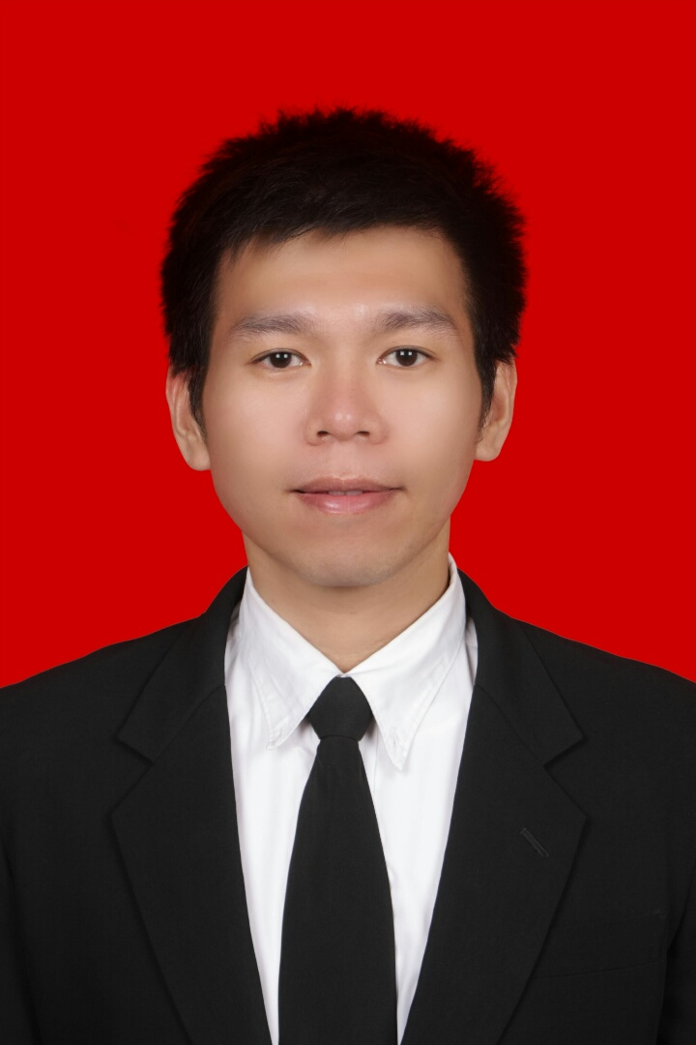 | Tjie Bun Tjae
 | (+62) 818560672 | chandra_tjie@yahoo.com | Surabaya, Jawa Timur – Indonesia.

Curriculum Vitae

PERSONAL DETAILS
Full name : Tjie Bun Tjae, S.Kom. / Alexander Chandra Tjieputra
Nickname : Chandra
Place and date of Birth : Ende, April 12th 1986 (30 Years old)
Sex : Male
Weight/High : 75kg / 180cm
Marital Status : Single
Religion : Chatolic
Nationality : Indonesian
Address : Wisma Permai Barat I Blok LL No. 37 Surabaya, Jawa Timur.
E-mail address : chandra_tjie@yahoo.com
Mobile Phone Number : +62 818 560 672 / +62813 6868 1986
Hobby : Playing Basketball, and Gym.

EDUCATION
Name | Place | Period
Information Technology, Duta Wacana Christian University Yogyakarta. | Yogyakarta,Indonesia | 2005 - 2013
Information Technology, STIKOM (LPBA) Denpasar. | Bali,Indonesia | 2004 – 2005
SMU TP 45 Tabanan (Senior High School). | Bali,Indonesia | 2001 - 2004
SLTP Negeri 2 Tabanan. | Bali,Indonesia | 1998 – 2001
SD Swasta Saraswati Tabanan. | Bali,Indonesia | 1992 – 1998
TK Santa Maria Immaculata Tabanan. | Bali,Indonesia | 1990 – 1992

Experience
4 years of total experience
Dec 2014 – Dec 2015  (1 Year ) |  | Area Sales Manager  PT. XL Axiata Tbk | Jawa Barat, Indonesia
 |  | Industry | Telecommunication
 |  | Specialization | Marketing/Business Development
 |  | Role | Business Development
 |  | Position Level | Manager / Assistant Manager
Job Description:
- Establish sales and distribution activities in Retail Outlet (Traditional Channel) to Achieve Sales Target.
- Analyze and evaluate dealer's sales operation having accurate / on time data and report in order to make correction and anticipation action.
- Join effort with Branch Manager dealer in developing Area to increase dealer productivity, profitability and Cluster Revenue.
- Collect and analysis market information to provide correction and anticipative action.
- Review and improve dealer sales team performance to optimize sales performance in order to ensure sales target achieved.
- Manages Team average 90 people.
Mar 2014 - Jan 2015  (1 Year) |  | Head Of Area  PT. Inbisco Niagatama Semesta ( Mayora ) | Jawa Tengah, Indonesia
 |  | Industry | Food & Beverage / Catering / Restaurant
 |  | Specialization | Marketing/Business Development
 |  | Role | Business Development
 |  | Position Level | Manager / Assistant Manager
- Making good relationship with all store in general market.
- To development in general trade market.
- To give the recommendation to Regional Manager and implement territory coverage development.
- To manage and control distribution activities (Plan of sales team, coverage and call frequency, brand distribution).
- Responsible for monthly target achievement for the sales division at my branch.
- Responsible for new product and all of our product distribution.
- Manage trade marketing activities with distributor sales teams.
- To provide required reporting correctly and timely.
- To do regular visit with fixed route and regular random audit outlet.
- Manages Team average 40 peoples.

June 2012 - Feb 2014  (2 Years ) |  | Retail Area Manager  PT. Infokom Putra Prima | Jawa Tengah, Indonesia
 |  | Industry | Computer / Information Technology (Hardware)
 |  | Specialization | Marketing/Business Development
 |  | Role | Business Development
 |  | Position Level | Manager / Assistant Manager
- Making good relationship with all Business Partners.
- To development in All Stores (Central Java & DIY).
- Making Reports to Director.
- To manage and control retailer activities (Plan of sales team/Stores).
- Responsible for monthly target achievement for All Stores.
- To provide required reporting correctly and timely.
- To do regular visit to all stores.
- Manages Team average 60 peoples.
Education
2005 - 2013 |  | Duta Wacana Christian University  Bachelor's Degree in Engineering (Computer/Telecommunication) | Indonesia
 |  | Major | Teknik Informatika
Skills
Intermediate |  | Microsoft Word, Microsoft Excel, Microsoft PowerPoint
Languages
Proficiency level: 0 - Poor, 10 - Excellent
Language |  | Spoken Written
Bahasa Indonesia (Primary) |  | 9 9
English |  | 6 6
Additional Info
Preferred Work Location |  | Yogyakarta, Jawa Tengah, Jawa Timur, and Bali.
Other Information
Expertise:
- Market Analisis
- Microsoft Office
- Manage Team
- Presentation Skill
- Target Oriented
- Able to work under pressure, highly motivaed, and good communication skill.
- Good initiative and have ability to work independently.
- Rapid Adaptation.

